The 7th Annual Island Creek Penguin Frostbite Regatta was held on November 13th at the Corkran estate on Island Creek. The day was perfect with shifting light breezes and temperatures in the mid 60s. A record 21 boats sailed making this by far the largest Penguin regatta of the year and the best attended ICPFR to date. The fleet was supported by some regular Penguin sailors but, more importantly, by many new and returning sailors.

Eric Wagner sailed with Penguin lifetime sailor Sewall Cox. Bill Lane’s son Matt brought crew Patrick Firth into the fleet and Emily Dupont returned after a 2 year absence with Brendan Gotowka. Eric Crawford loaned his beautiful boat to son Eddie who sailed with Suzy Cox. Cathy Schmidt brought the boat she has owned since childhood and enlisted husband Brian as crew. Liz Wainwright, who sailed with Caroline Benson to a fine second place in the first race, can hardly be counted in this group as she returns with regularity from her home in Manhattan. Solo sailor John Shannahan put in a rare appearance and John Danly gave up his regular duties as boat launcher to sail with his brother Bill. Local sailors Harry Callahan and Log Canoe stalwart Tad Dupont were also welcomed to the fleet. New Penguin sailors Matt Fafoutis and Bryn Bachman borrowed one of Charlie Krafft’s fleet of boats and Philip Logan used Scott Williamson’s Powder Monkey.

As usual this event was actually a huge party hosted by Kim Corkran, her extended family and the entire Island Creek neighborhood. The partygoers and support team outnumbered the sailors by a good margin. Everyone with any connection to sailing in general and Penguins in particular was there. Doug Firth handled race committee duties and set very welcome square lines and courses for the five races.

Although the top of the fleet was dominated by recent outstanding Penguin Sailors returning Penguin sailor Andrew Parrish and daughter Addison started off with a win in the first race to round out the top five. John Majane singlehanded to an excellent sixth. Aubrey Barringer showed super boat speed finish as first crew in the crew race in which Charlie Krafft’s crew Donna McKenzie placed second and Gray Benson third.

More importantly food and drink were present in abundance and the raw oysters were especially succulent this year.

Thanks again to Kim, her family and all their friends.

Paul Hull
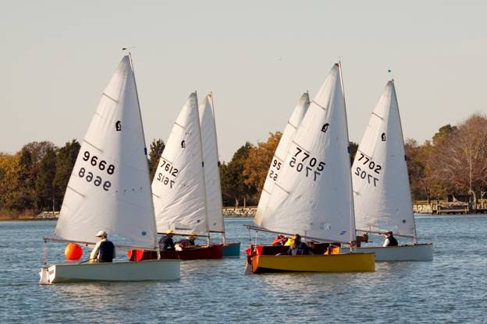

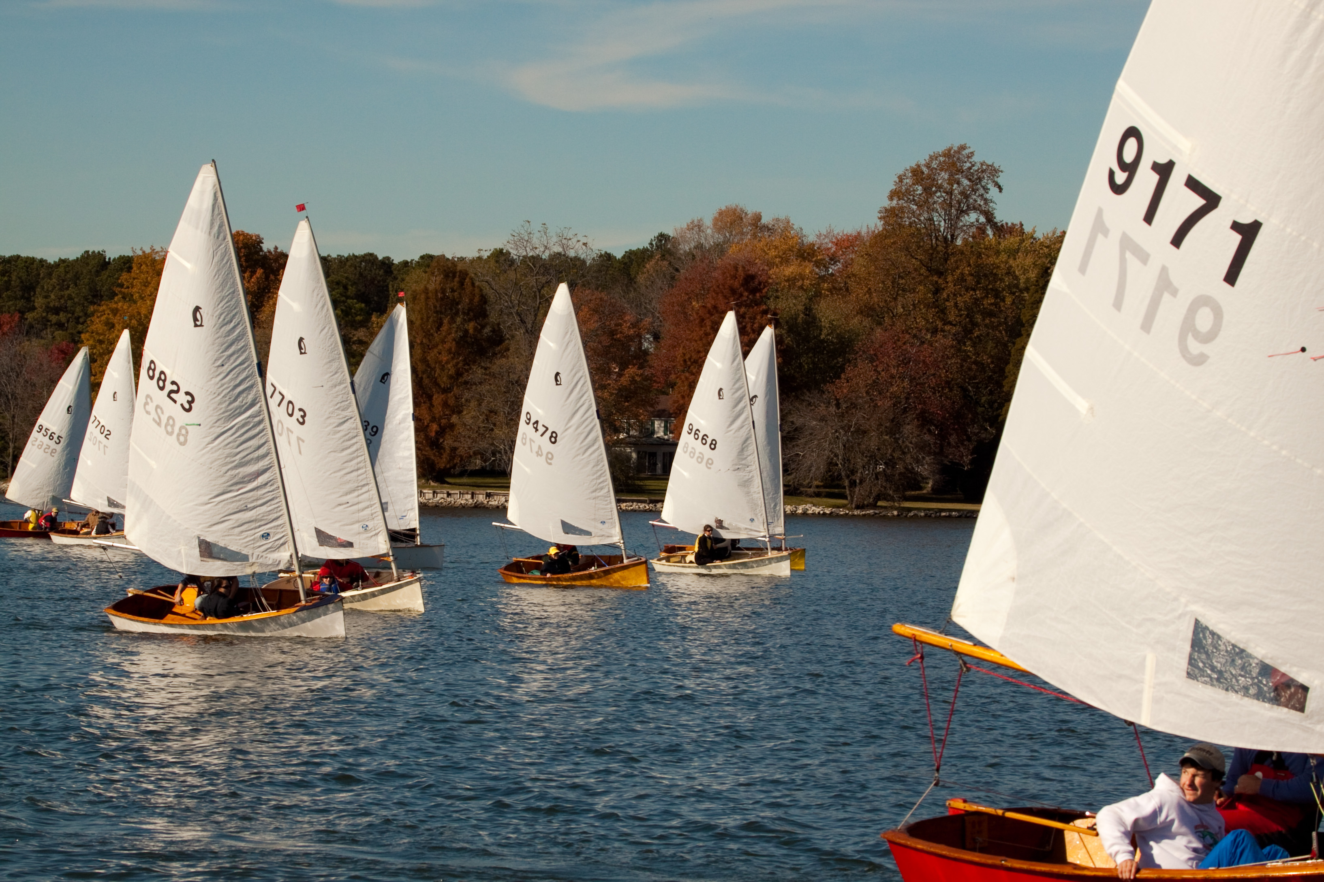

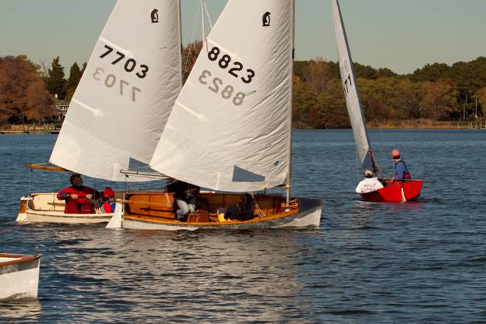

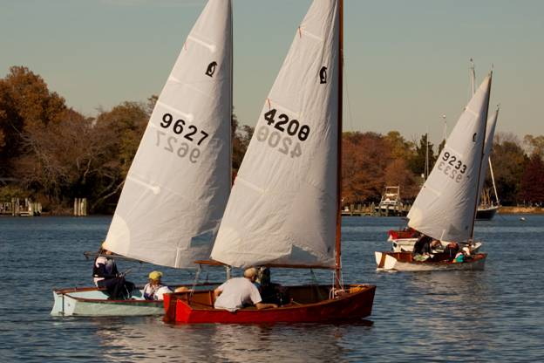

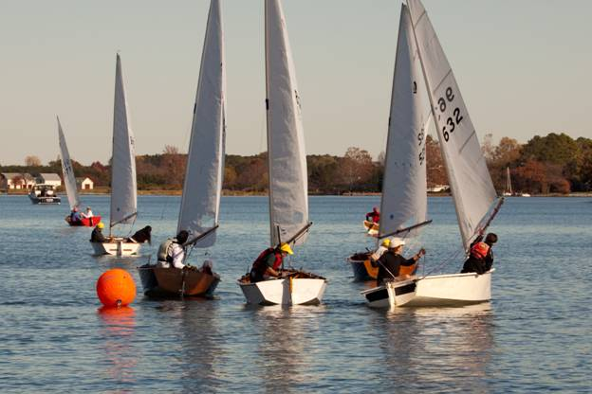

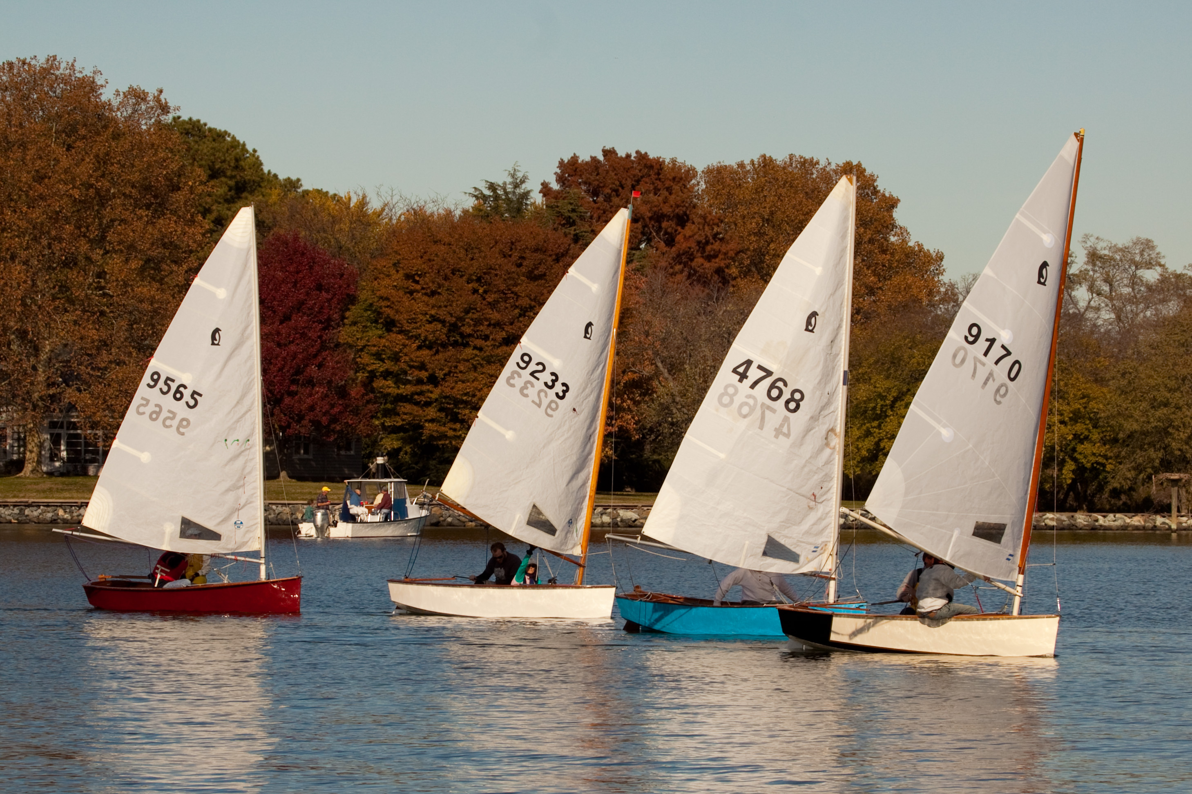

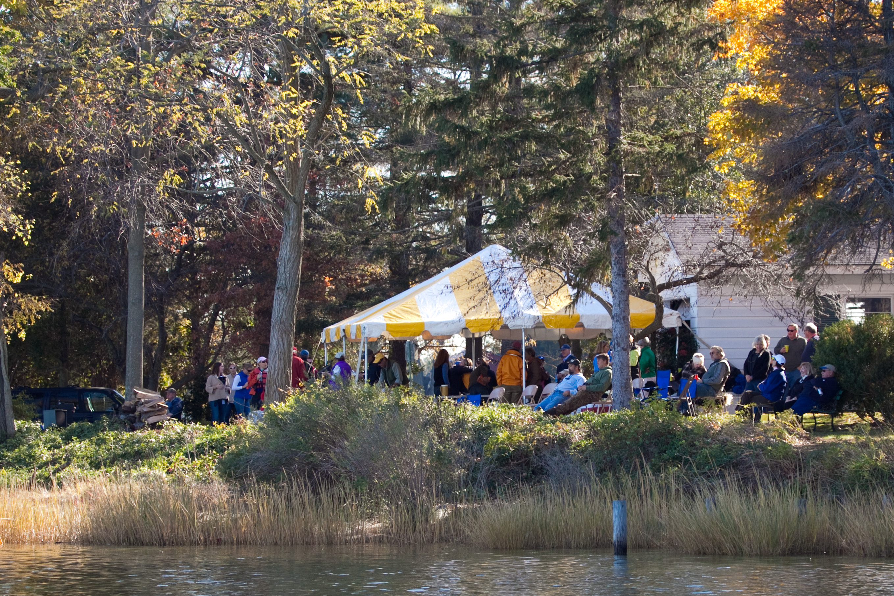

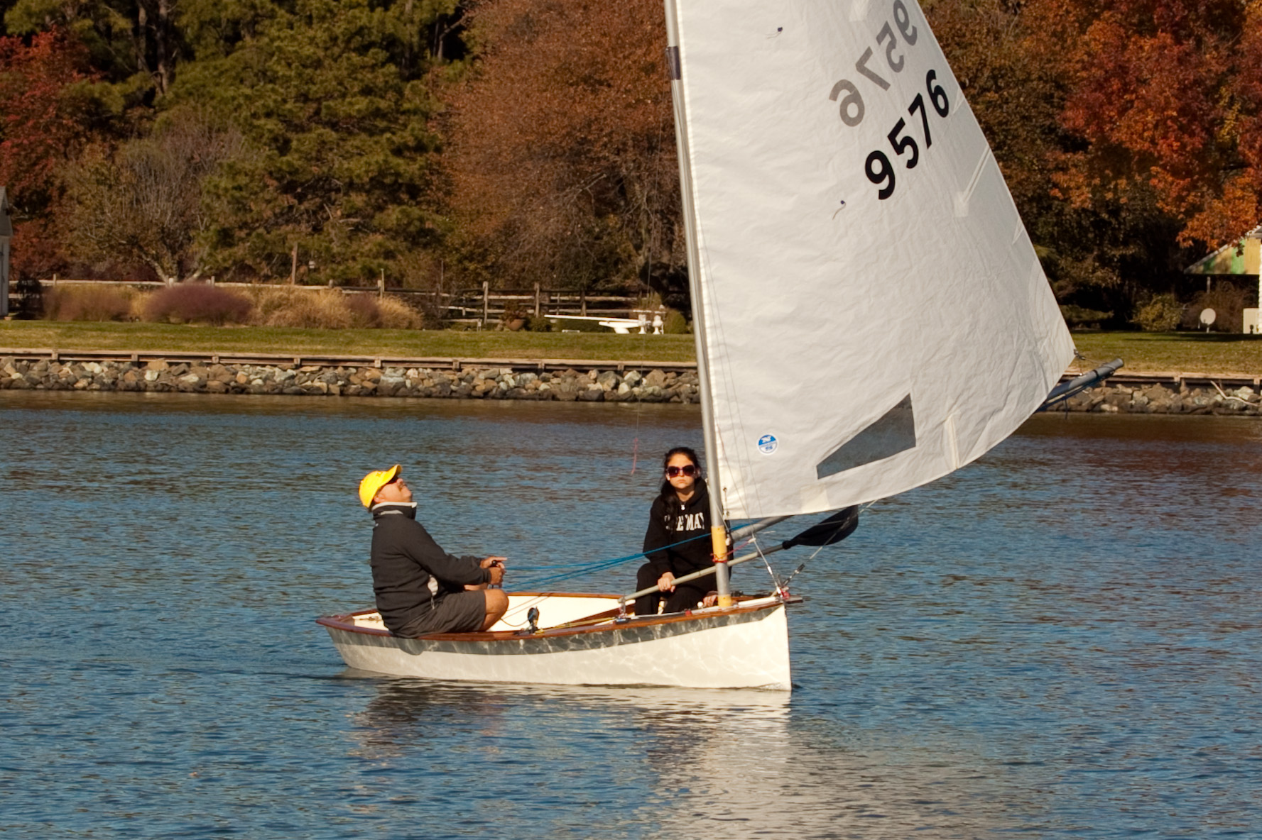

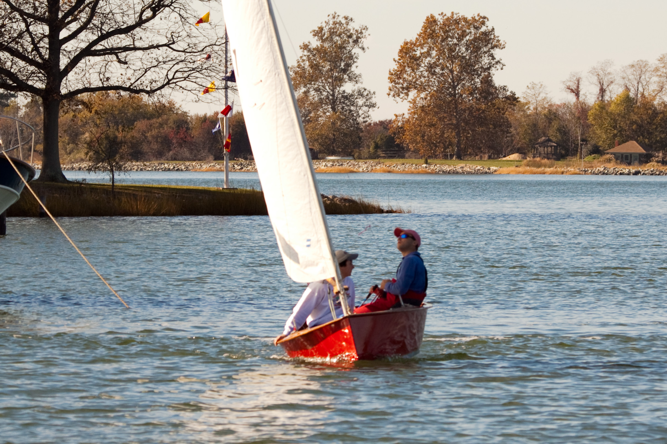

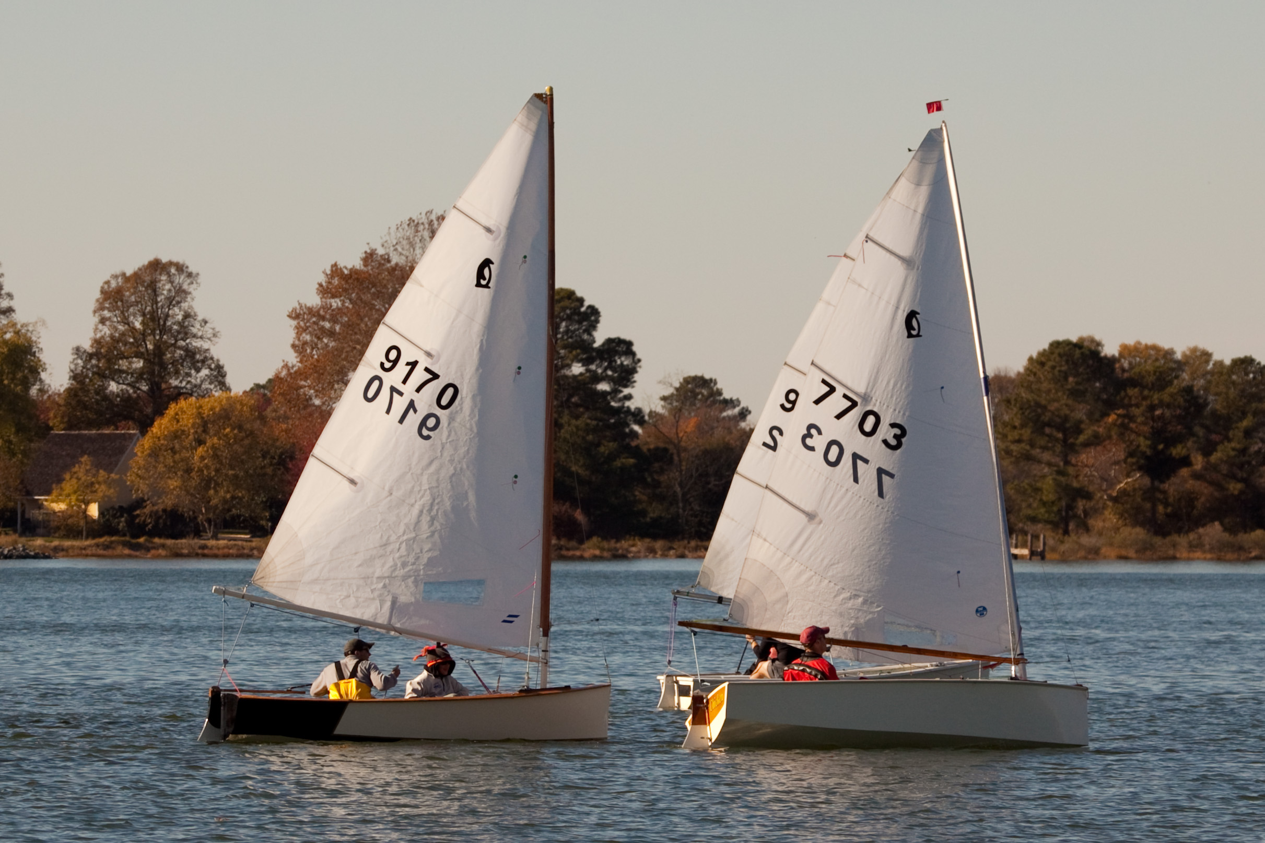

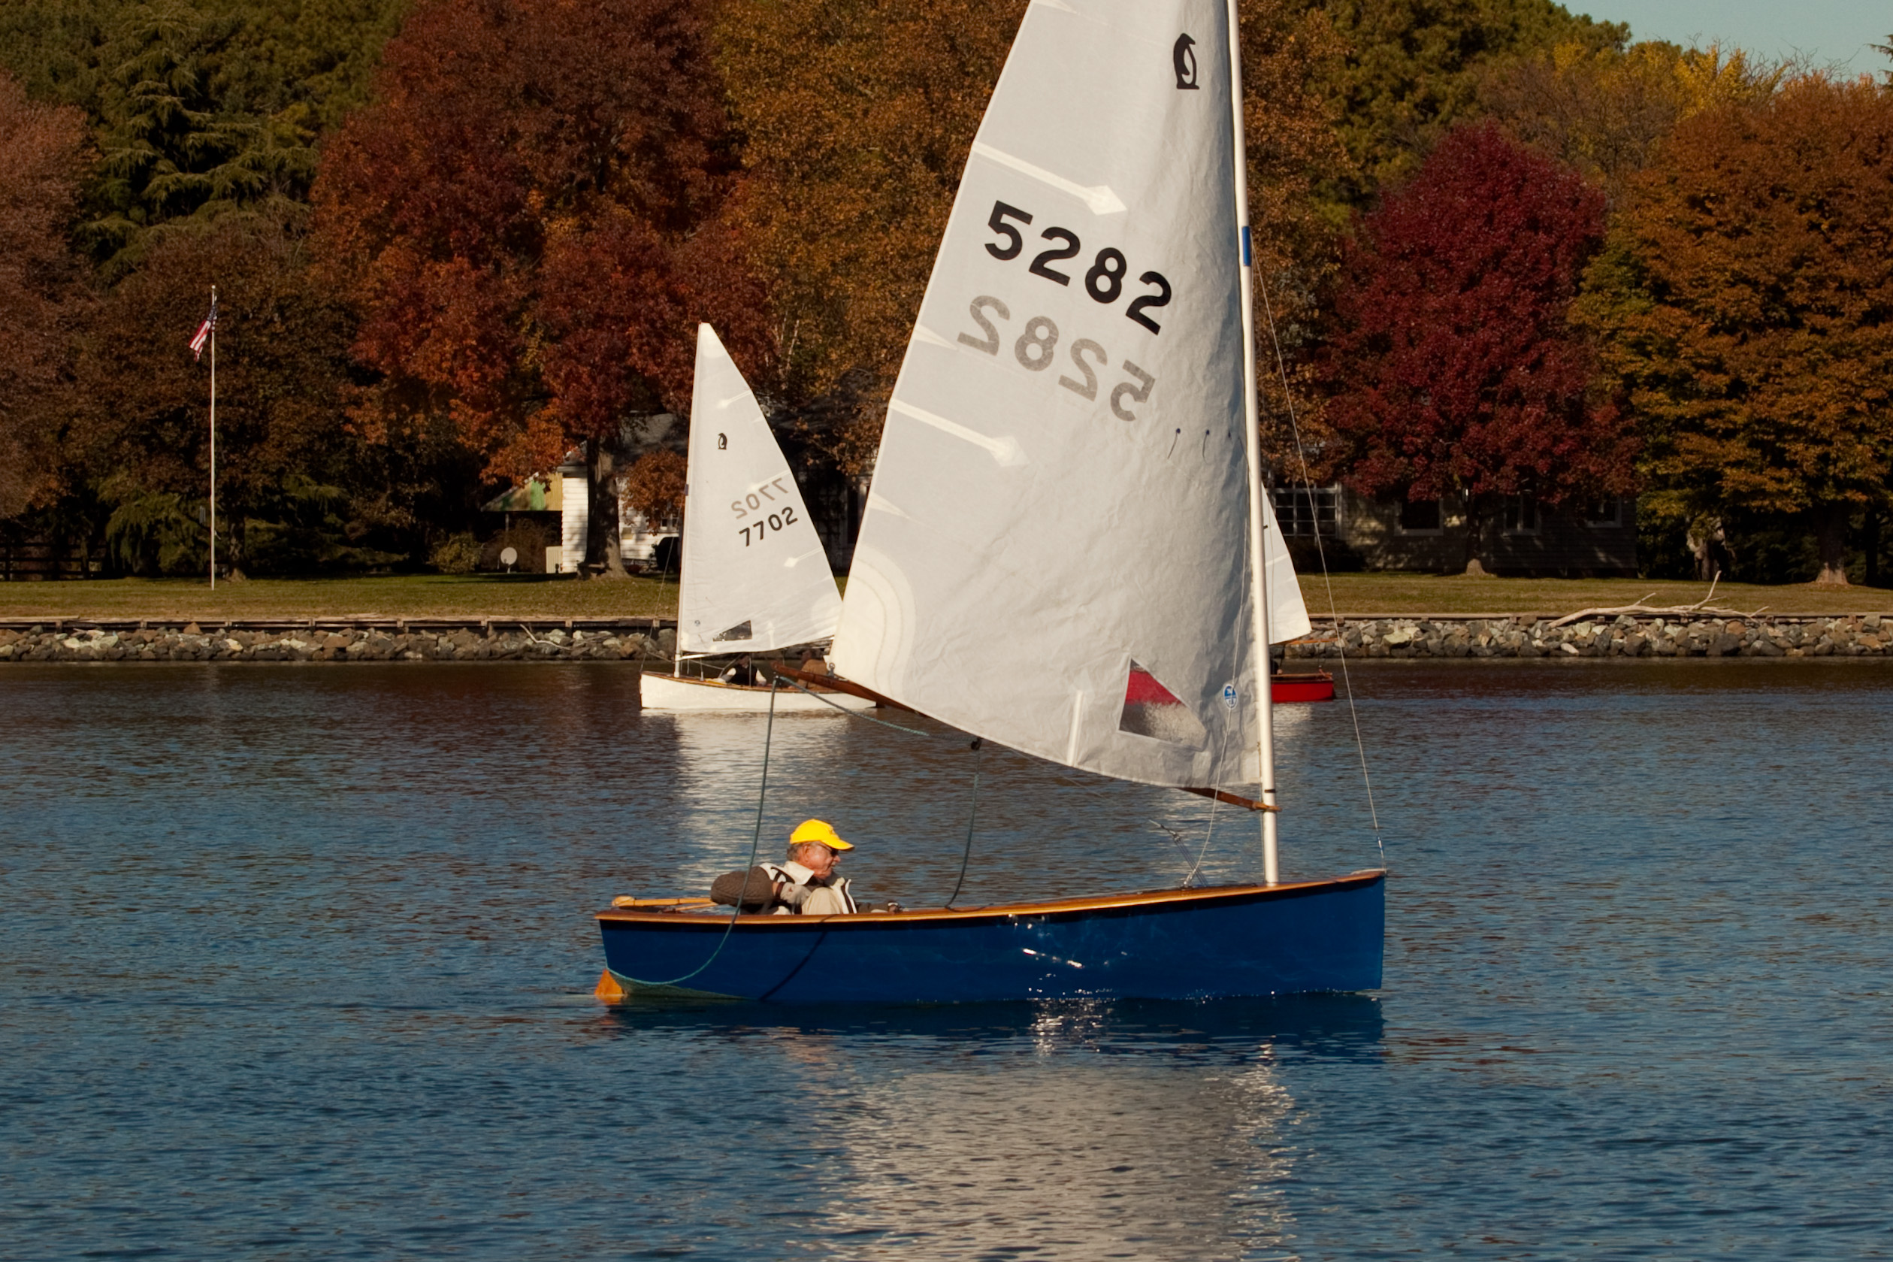

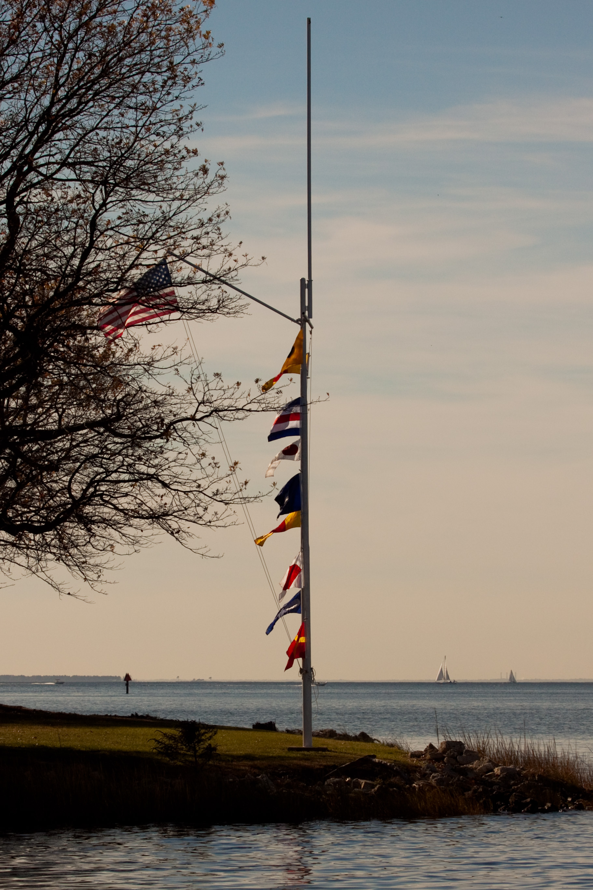
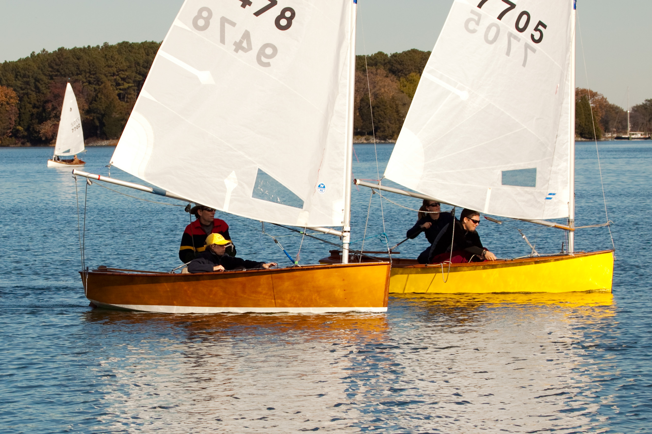

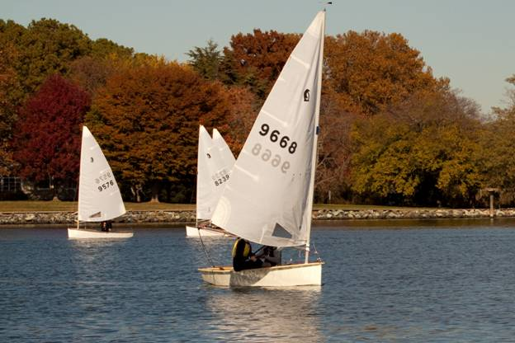

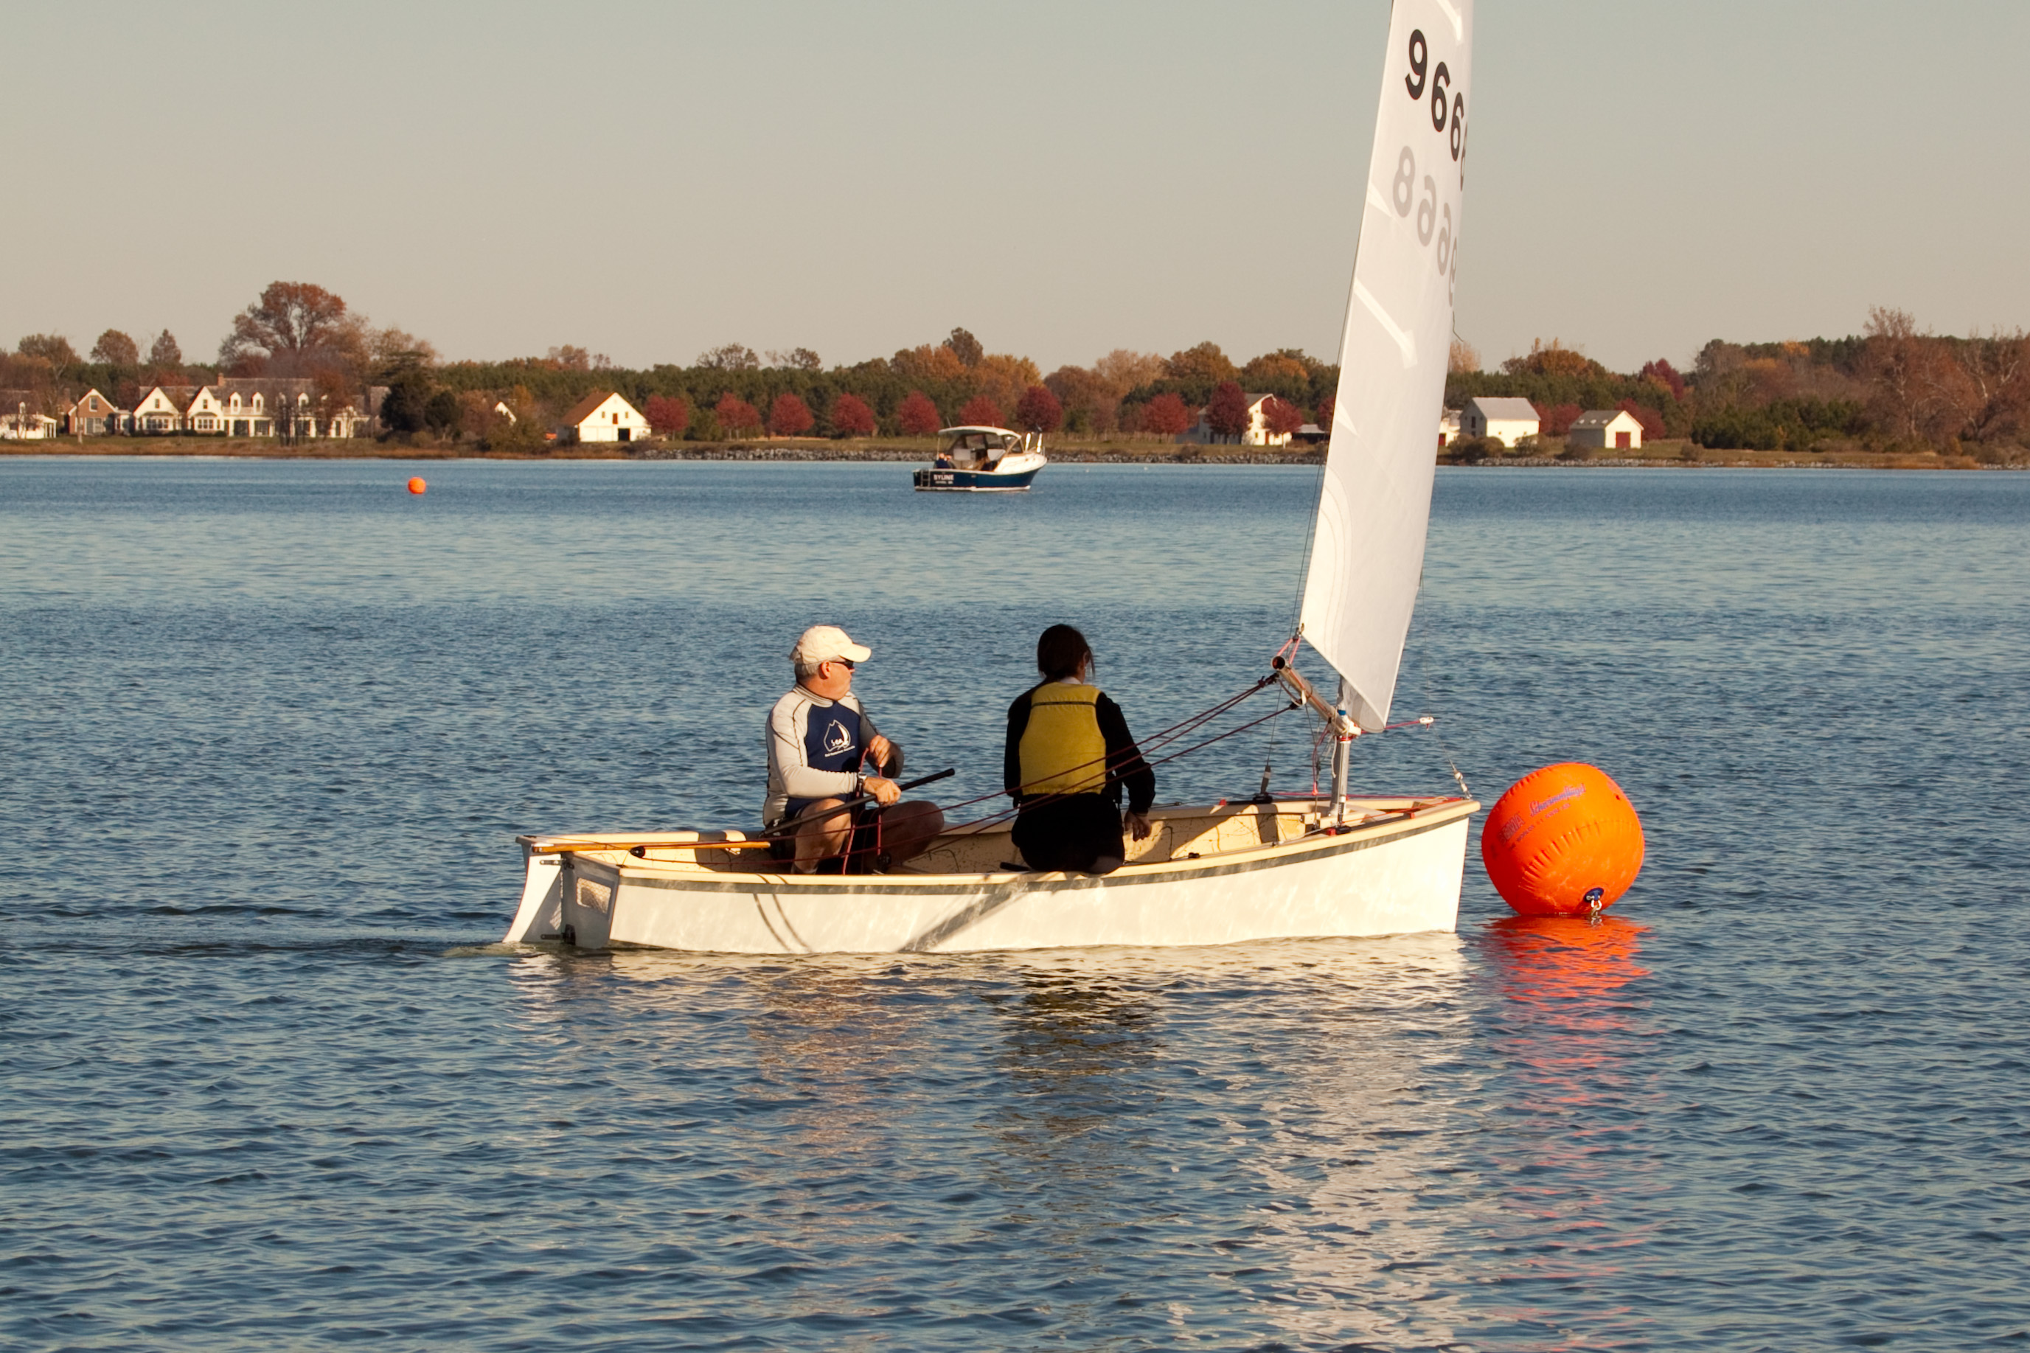

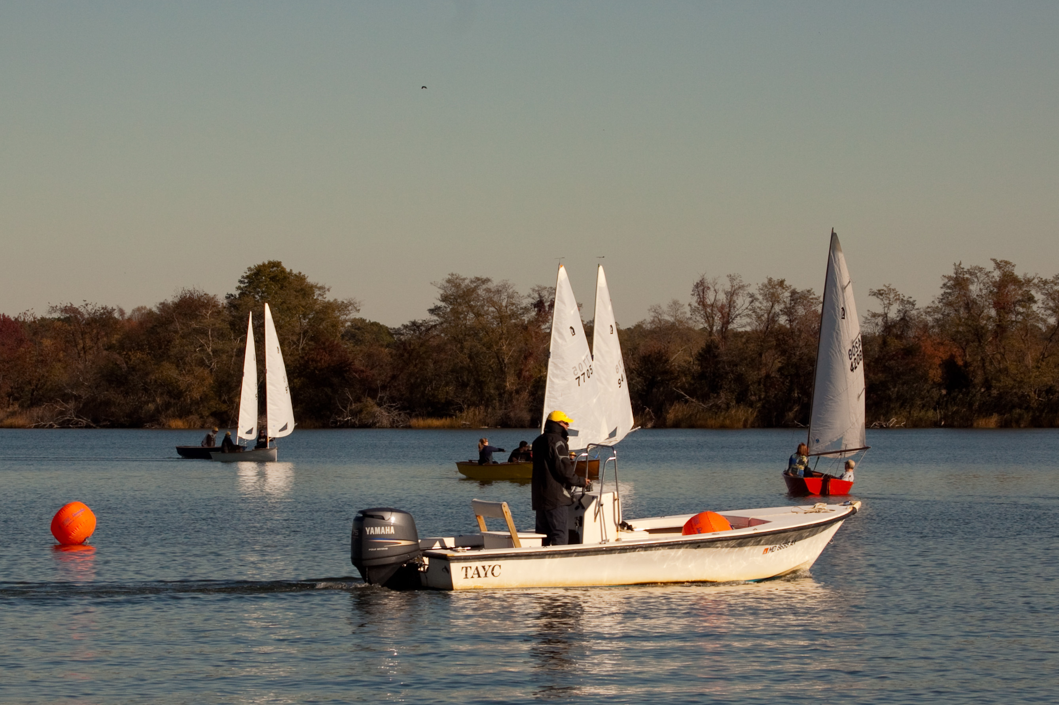

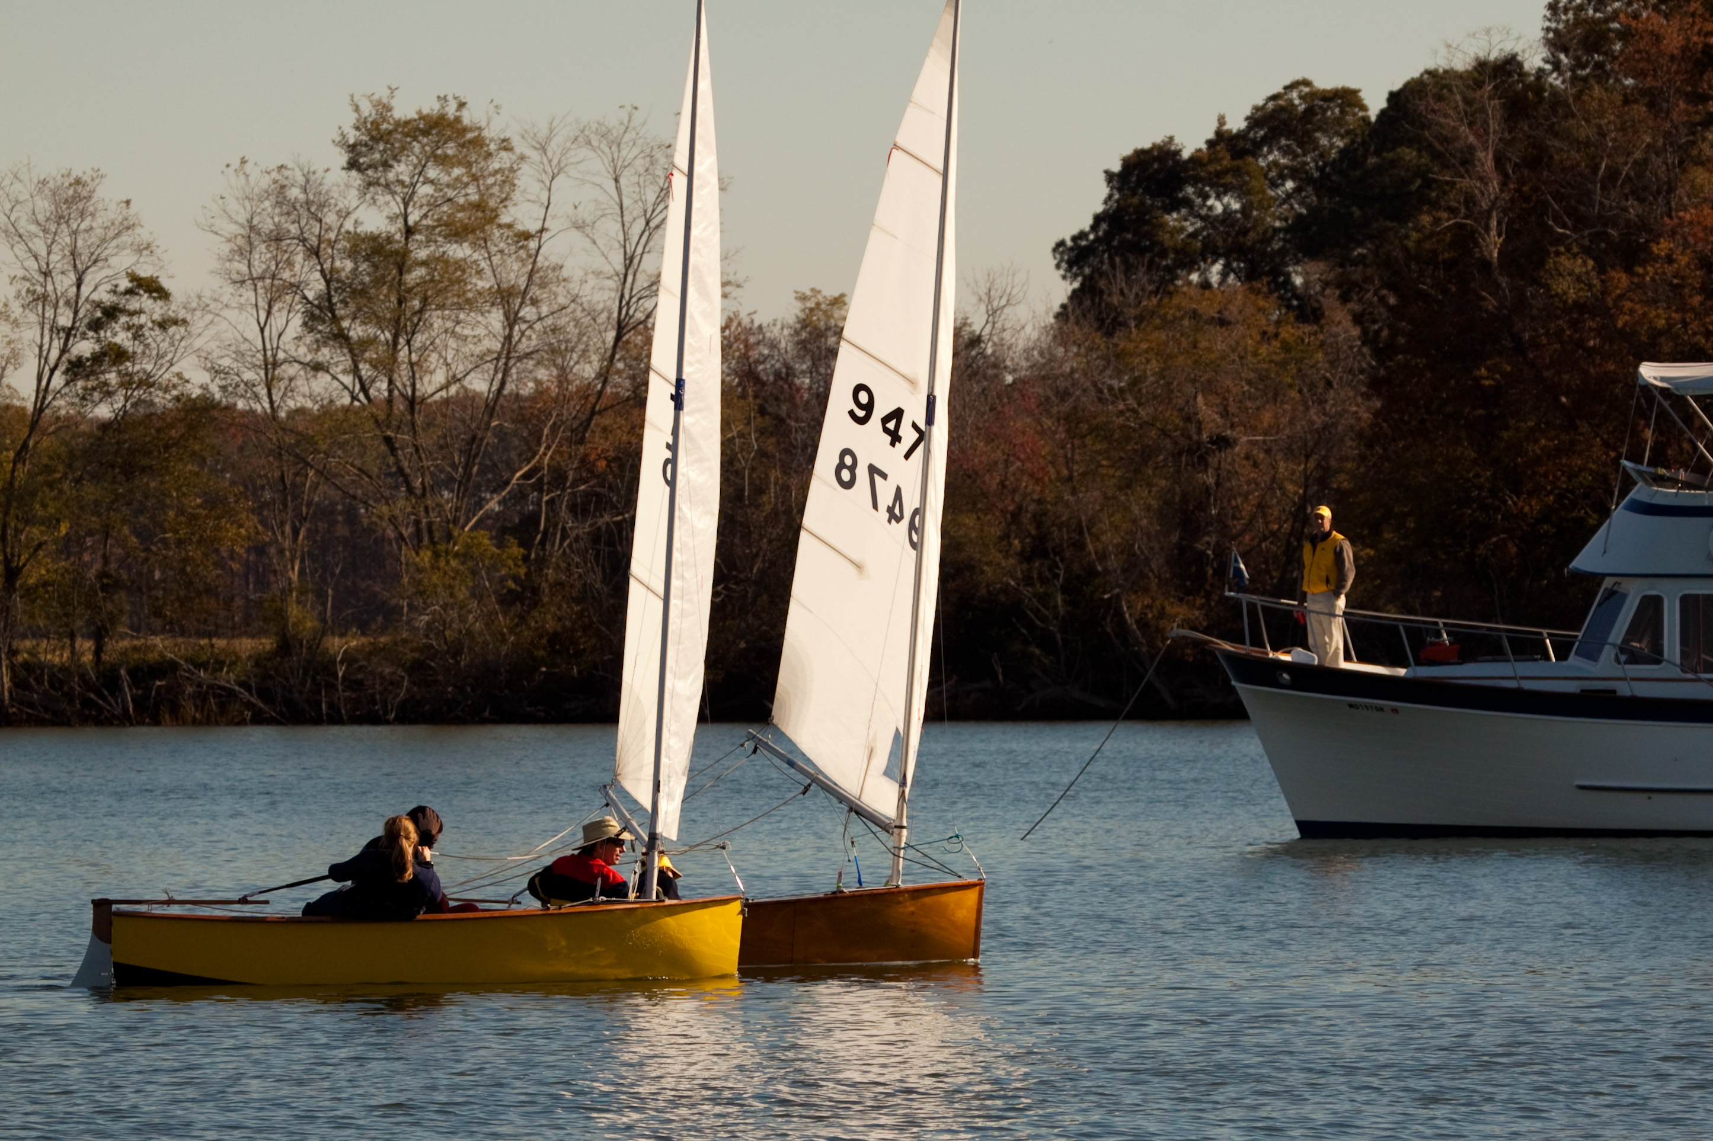

Results

